Gary Miller
Lab 3

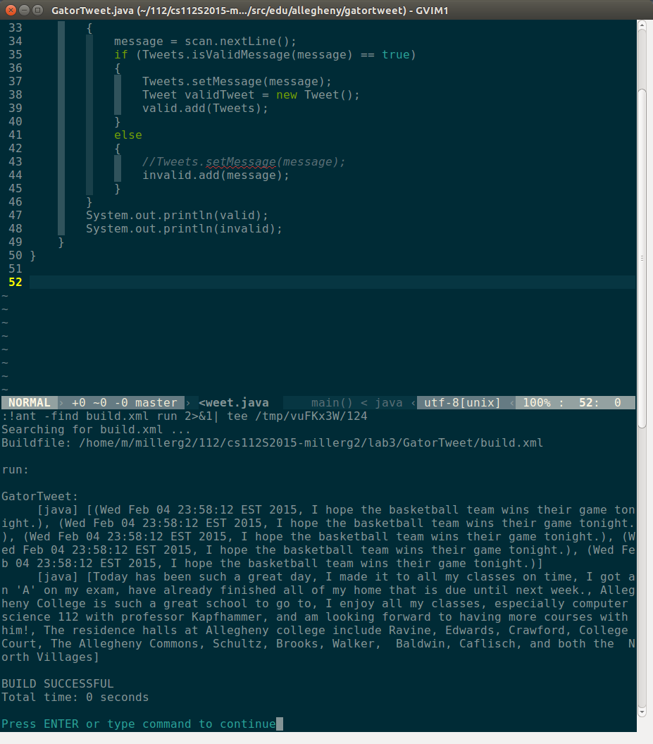
The meaning and purpose of the file build.xml is to define the directories, variables, and terminal commands for the classes Tweet.java and GatorTweet.java. When using the “Ant compile” command in gvim, both classes are compiled at the same time. Not only do they compile, but should have any errors, the “Ant compile” command explains what the error is and shows the user which line is responsible for the error. Also, the build.xml file allows to user to run the programs right in gvim with the output appearing on the screen.

Output:
GatorTweet:
[java] Valid Tweets: [(Thu Feb 05 00:01:26 EST 2015, I hope the basketball team wins
their game tonight.), (Thu Feb 05 00:01:26 EST 2015, I hope the basketball team wins their
game tonight.), (Thu Feb 05 00:01:26 EST 2015, I hope the basketball team wins their game
tonight.), (Thu Feb 05 00:01:26 EST 2015, I hope the basketball team wins their game toni
ght.), (Thu Feb 05 00:01:26 EST 2015, I hope the basketball team wins their game tonight.)
]
[java] Invalid Tweets: [Today has been such a great day, I made it to all my classes
on time, I got an 'A' on my exam, have already finished all of my home that is due until n
ext week., Allegheny College is such a great school to go to, I enjoy all my classes, espe
cially computer science 112 with professor Kapfhammer, and am looking forward to having mo
re courses with him!, The residence halls at Allegheny college include Ravine, Edwards, Cr
awford, College Court, The Allegheny Commons, Schultz, Brooks, Walker, Baldwin, Caflisch,
and both the North Villages]

